SDD/SWDD: Draft Planning Proposal

| **Authors**  · Colin Griffin  · Msanaa Bosland | **Functional Description:**  This software will be able to:   * Store the data of athletes in Track and Field, Swimming, and Cross Country at the collegiate level. |
| --- | --- |
| **User Interface:**  · System (phone, web, desktop)  · See attached Wireframe for example of interface. (Figure 1) | **Data-Driven Prioritization**  We have decided to use an API (Application Programming Interface) For our database. The API is able to get all of the data off the official meet results website and then it is up to us what we do with this data. Which we will use on our website. |
| **Goals & milestones:**  Epics:   * Making Sure the database is running and functioning in collaboration with the website.   Milestones:   * Create a functioning prototype * Sort and organize times, events, athletes and universities of each sport. * Creating a program that can automatically pull information from live meets.   User Stories:   * As a user, I want to be able to access a page of only athlete’s that I have favorited, so that I can easily find the information on athlete’s that I am interested in. * As a user I want to be able to view all of the meets in one day so I am able to compare different meets and their competition. * As a user, I want to be able to easily maneuver between different Main Information Pages for specific sports and to and from the home page, so that I can smoothly and efficiently interact with the database. | |
| **Timeline** | |
| **Current and proposed solutions**  Currently there are multiple databases that hold information on high level athletics, for example TFRRS is the go to for all track and field/cross country athletes. This is a website that is confusing and is often buggy on mobile.  On the swim side of things, there is Swimcloud. Swimcloud is a website that holds the times of swimmers in a database and displays it to users, however it could often be inaccurate or not display all the information available on a swimmer.  There is no centralized place that holds this information for multiple sports, thus we are creating CMTD as a centralized database that displays the times of collegiate level athletes in one location. | |

# Figures

Label and include any updated figures here (using Heading 2 to label them & you can just find them with navigation pane). DO NOT NEED Use-Case diagram at this point! Should have a Class UML ( or DFD) for showing the technical makeup of your system (or ERD as it applies), priority matrix, wireframes/storyboards, and any other figure you think helps (risk matrix, 4Ls, MoSCoW or Kano, etc.)

## Prioritization Matrix

**Caption**: This was directly taken from<https://www.lucidchart.com/blog/how-to-create-software-design-documents>

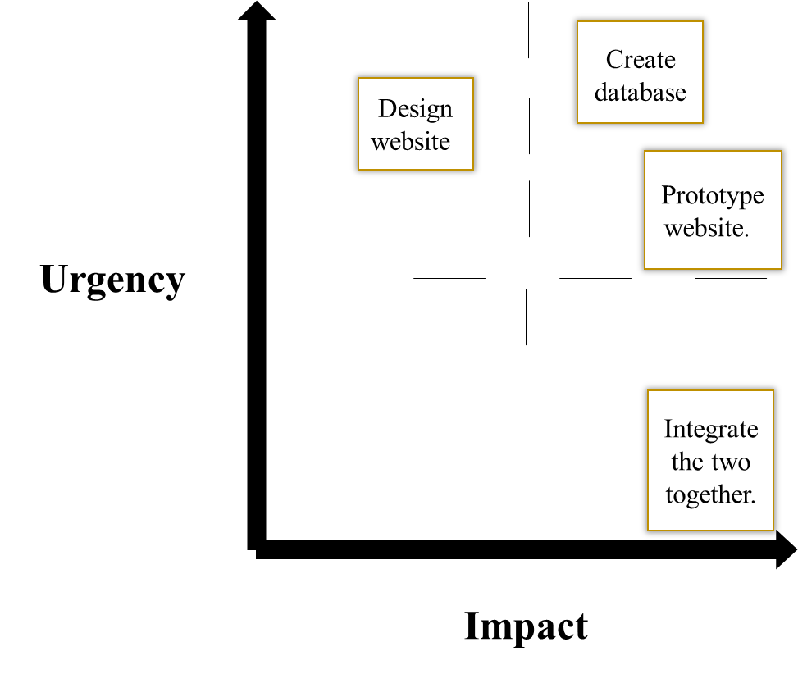

Figure 1:(CMTD Wireframe)

